

**Evolution of Computers**

Historical Development of Computers



June 1, 2025

Exceed Advanced Software training

Megenagna

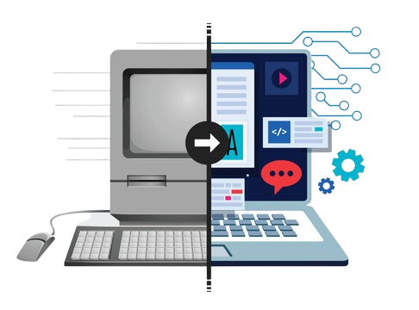

**Historical Development**

**of Computers**

T

he history of computers is a fascinating journey of innovation, beginning with large, room-sized machines and evolving into powerful, portable devices we use today.

First Generation (1940–1956) – Vacuum Tubes

* Used **vacuum tubes** for circuitry and magnetic drums for memory.
* Very large, expensive, and generated a lot of heat.
* Input: Punched cards and paper tape.
* Output: Printouts.

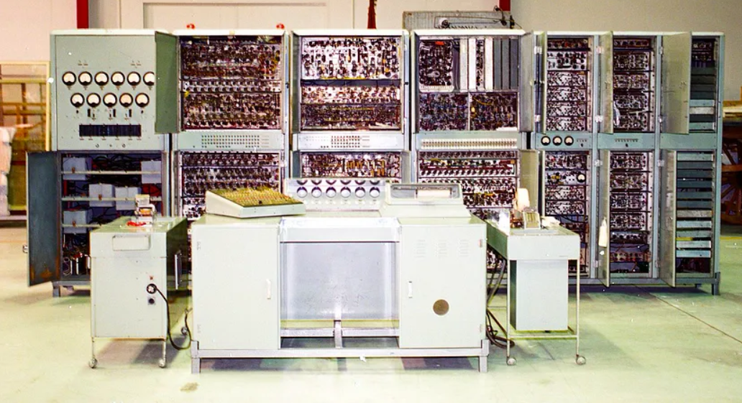

Second Generation (1956–1963) – Transistors

* Used **transistors** instead of **vacuum tubes**.
* Smaller, faster, cheaper, and more reliable.
* 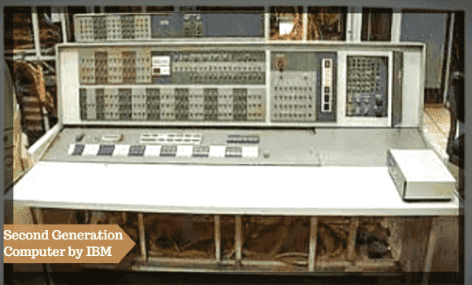Used assembly language and early versions of high-level programming languages (e.g., COBOL, FORTRA

Third Generation (1964–1971) – Integrated Circuits

* Used **integrated circuits (ICs)**, which increased speed and efficiency.
* Smaller size and more powerful.
* Key development: operating systems and multiprogramming.
* **Example**: IBM System/360.

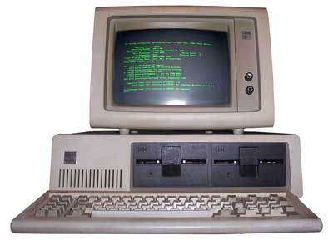

Fourth Generation (1971–Present) – Microprocessors

* Introduced **microprocessors**, where thousands of ICs were built onto a single silicon chip.
* Emergence of personal computers (PCs).
* Use of GUI, mouse, and high-level programming languages.
* **Example**: Apple II, IBM PC, Intel 4004 (first microprocessor).

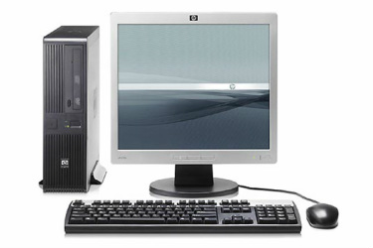

Fifth Generation (Present and Beyond) – Artificial Intelligence

* Based on **AI**, machine learning, and quantum computing (still developing).
* Use of parallel processing, natural language processing, robotics.
* Focus on intelligent systems.
* **Examples**: Modern AI-based systems, quantum computers, smart assistants.

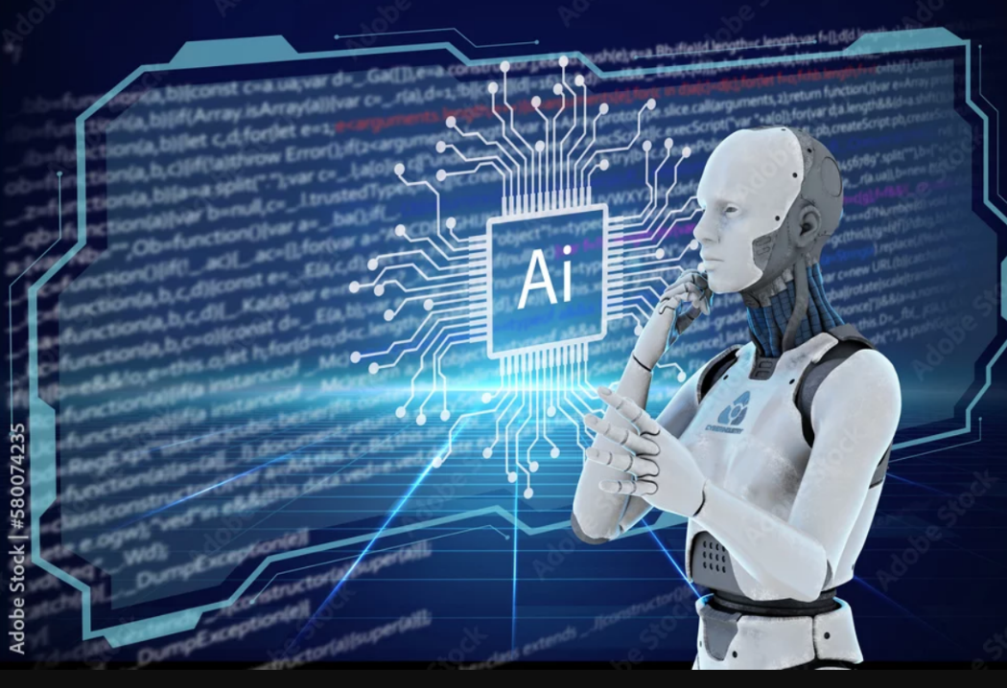

|  |  |  |  |
| --- | --- | --- | --- |
| Evolution of Computers by Generations | | | |
| **Generation** | **Time Period** | **Technology Used** | **Example** |
| **1st Generation** | 1940–1956 | Vacuum Tubes | ENIAC, UNIVAC |
| **2nd Generation** | 1956–1963 | Transistors | IBM 1401 |
| **3rd Generation** | 1964–1971 | Integrated Circuits (ICs) | IBM System/360 |
| **4th Generation** | 1971–Present | Microprocessors | Apple II, IBM PC |
| **5th Generation** | Present–Future | AI & Quantum Computing | AI Assistants, Quantum PCs |